Crochet Flower: Forget Me Not Pattern
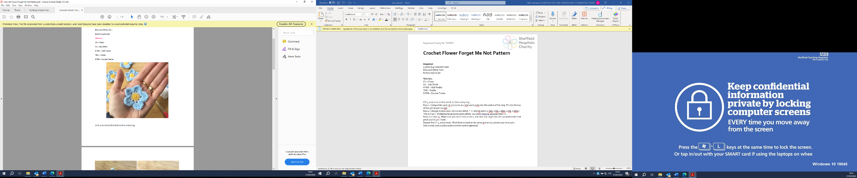
Required:
3.5mm (E4) Crochet Hook
Blue and White Yarn
Button (optional)

Stitches:
Ch – Chain
SS – Slip Stitch
HTRB – Half Treble
TRB – Treble
DTRB – Double Treble

Ch 4, SS to into to first stitch to form a tiny ring.
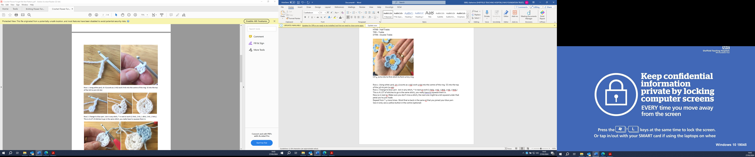

Row 1: Using white yarn, Ch 3 (counts as 1TRB) work 9TRB into the centre of the ring. SS into the top of the 3 Ch to join (10 sts)

Row 2: Change to blue yarn. Join in any stitch, * in next st work (1HTRB, 2TRB, 1DTRB, 2TRB, 1HTRB). This is A LOT of stitches to go in the same stitch, you really have to squeeze them in.

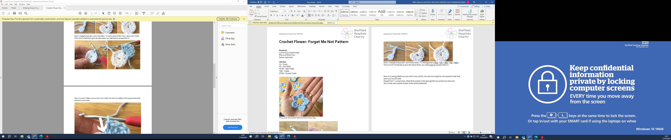

Now SS in next st. Make sure you don’t miss a stitch, the next one might be a bit squared under that petal you’ve just made.
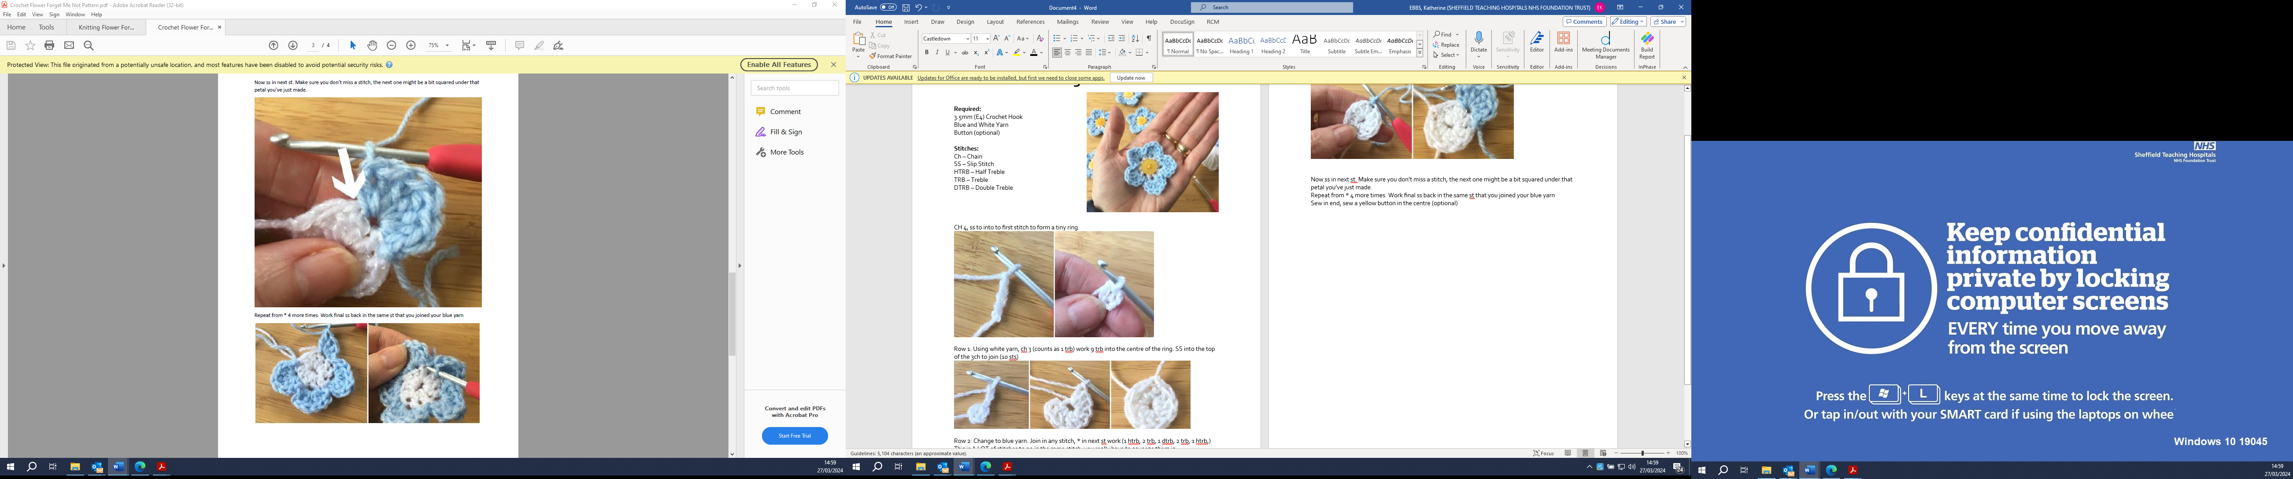

Repeat from * 4 more times. Work final SS back in the same st that you joined your blue yarn. Sew in end, sew a yellow button in the centre (optional)
Please send all completed Forget Me Nots to:
Wycliffe House
Northern General Hospital
Herries Road
S5 7AT

